**YELP DATASET CHALLENGE**

<https://www.yelp.com/dataset_challenge>

**Analysis 1:** What is average stars of businesses in a neighborhood in every city?

Steps:

1. Run analysis 1 of Hadoop

**Analysis 2:** Find month wise consumption of each cuisine.

Steps:

1. Run analysis 2 of Hadoop
2. Run analysis 2 of pig

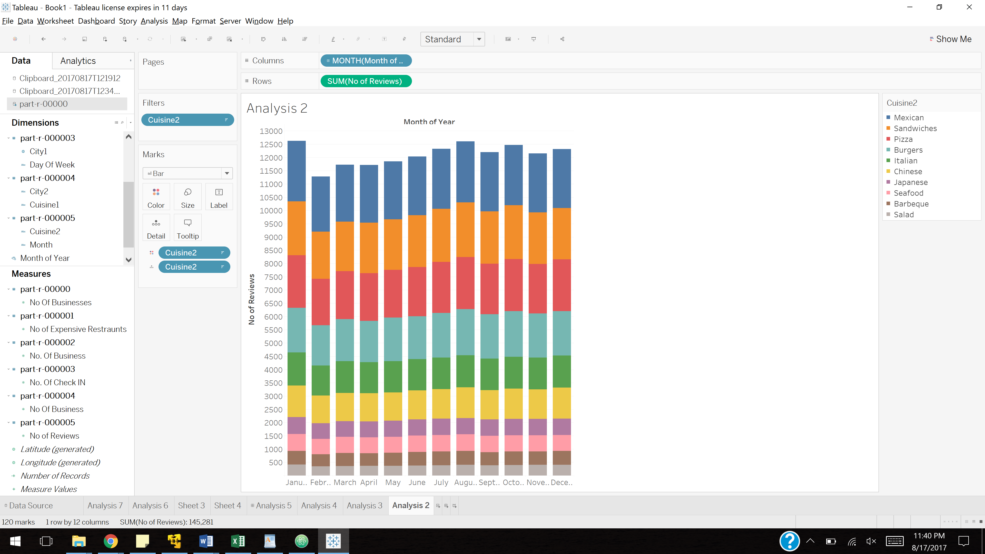

**Analysis 3:** Top 5 cuisines of each city

Steps:

1. Run analysis 3 of Hadoop
2. Run analysis 3 of pig

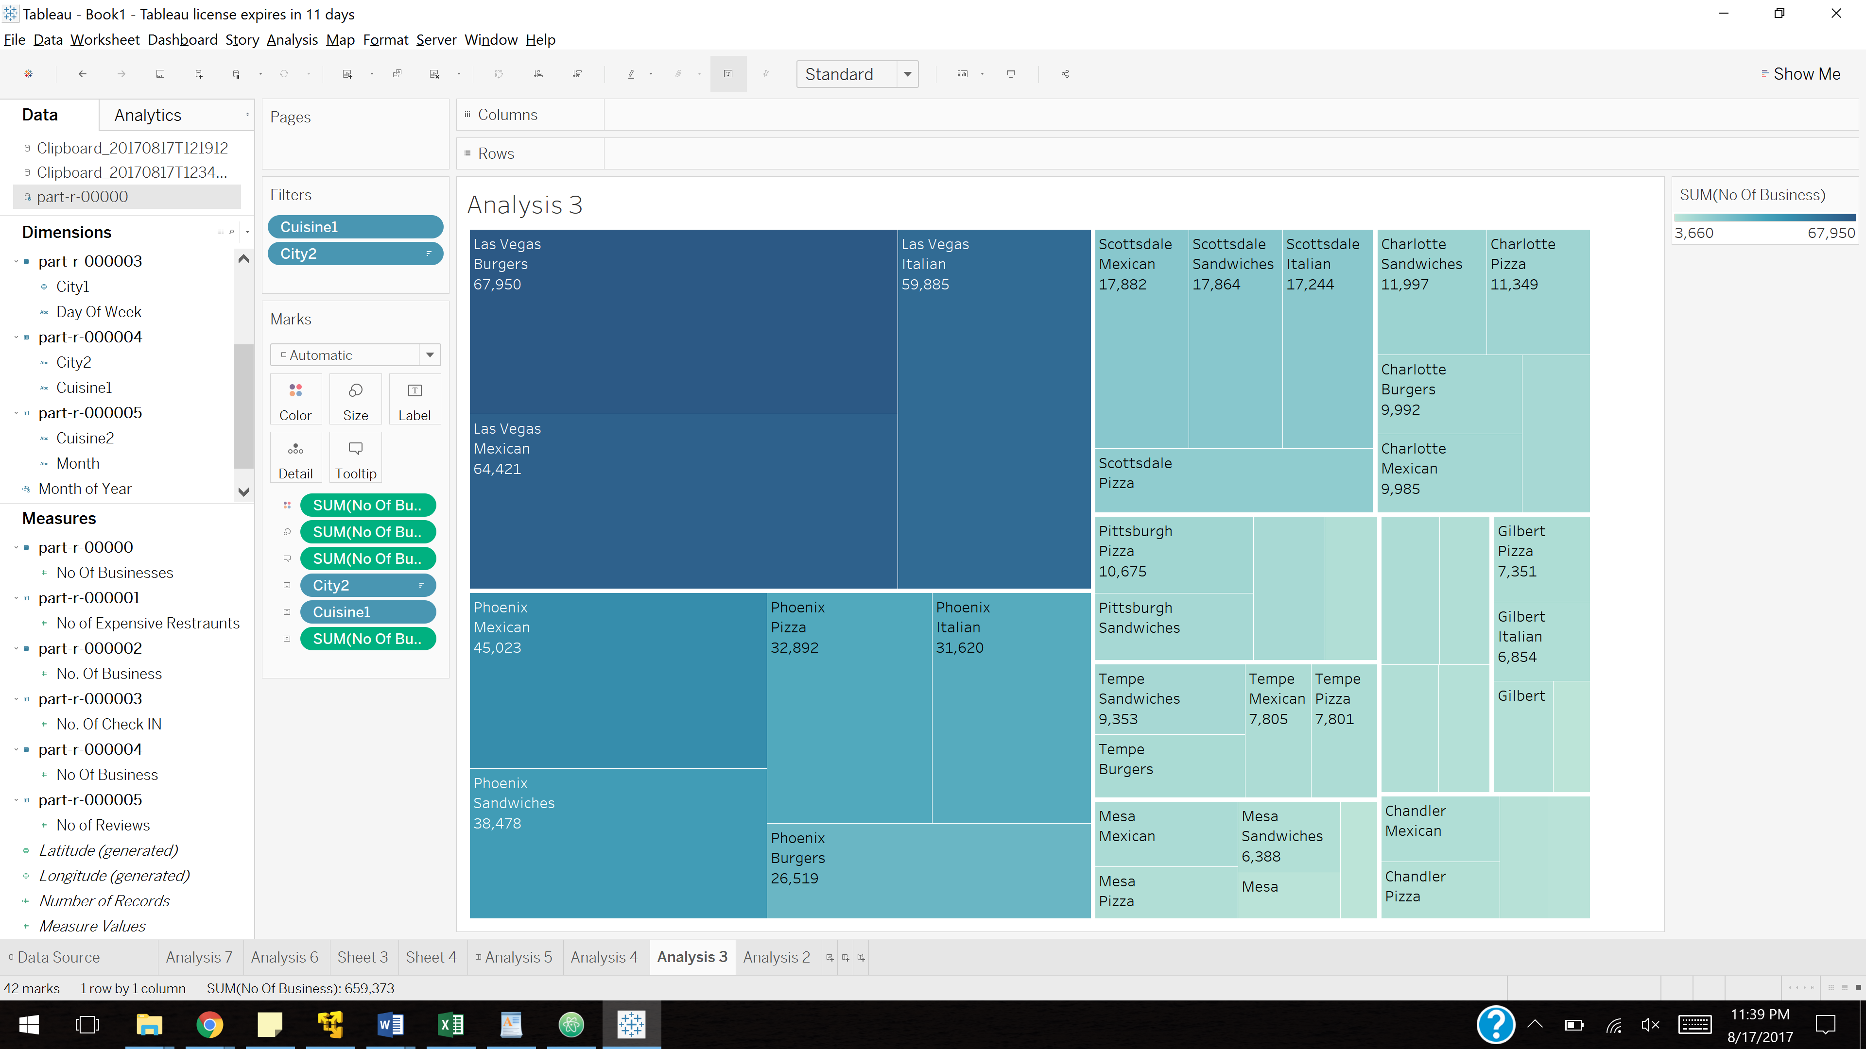

**Analysis 4:** Finding average weekly check-ins from each city

Steps:

1. Run analysis 4 of Hadoop
2. Run analysis 4 of pig

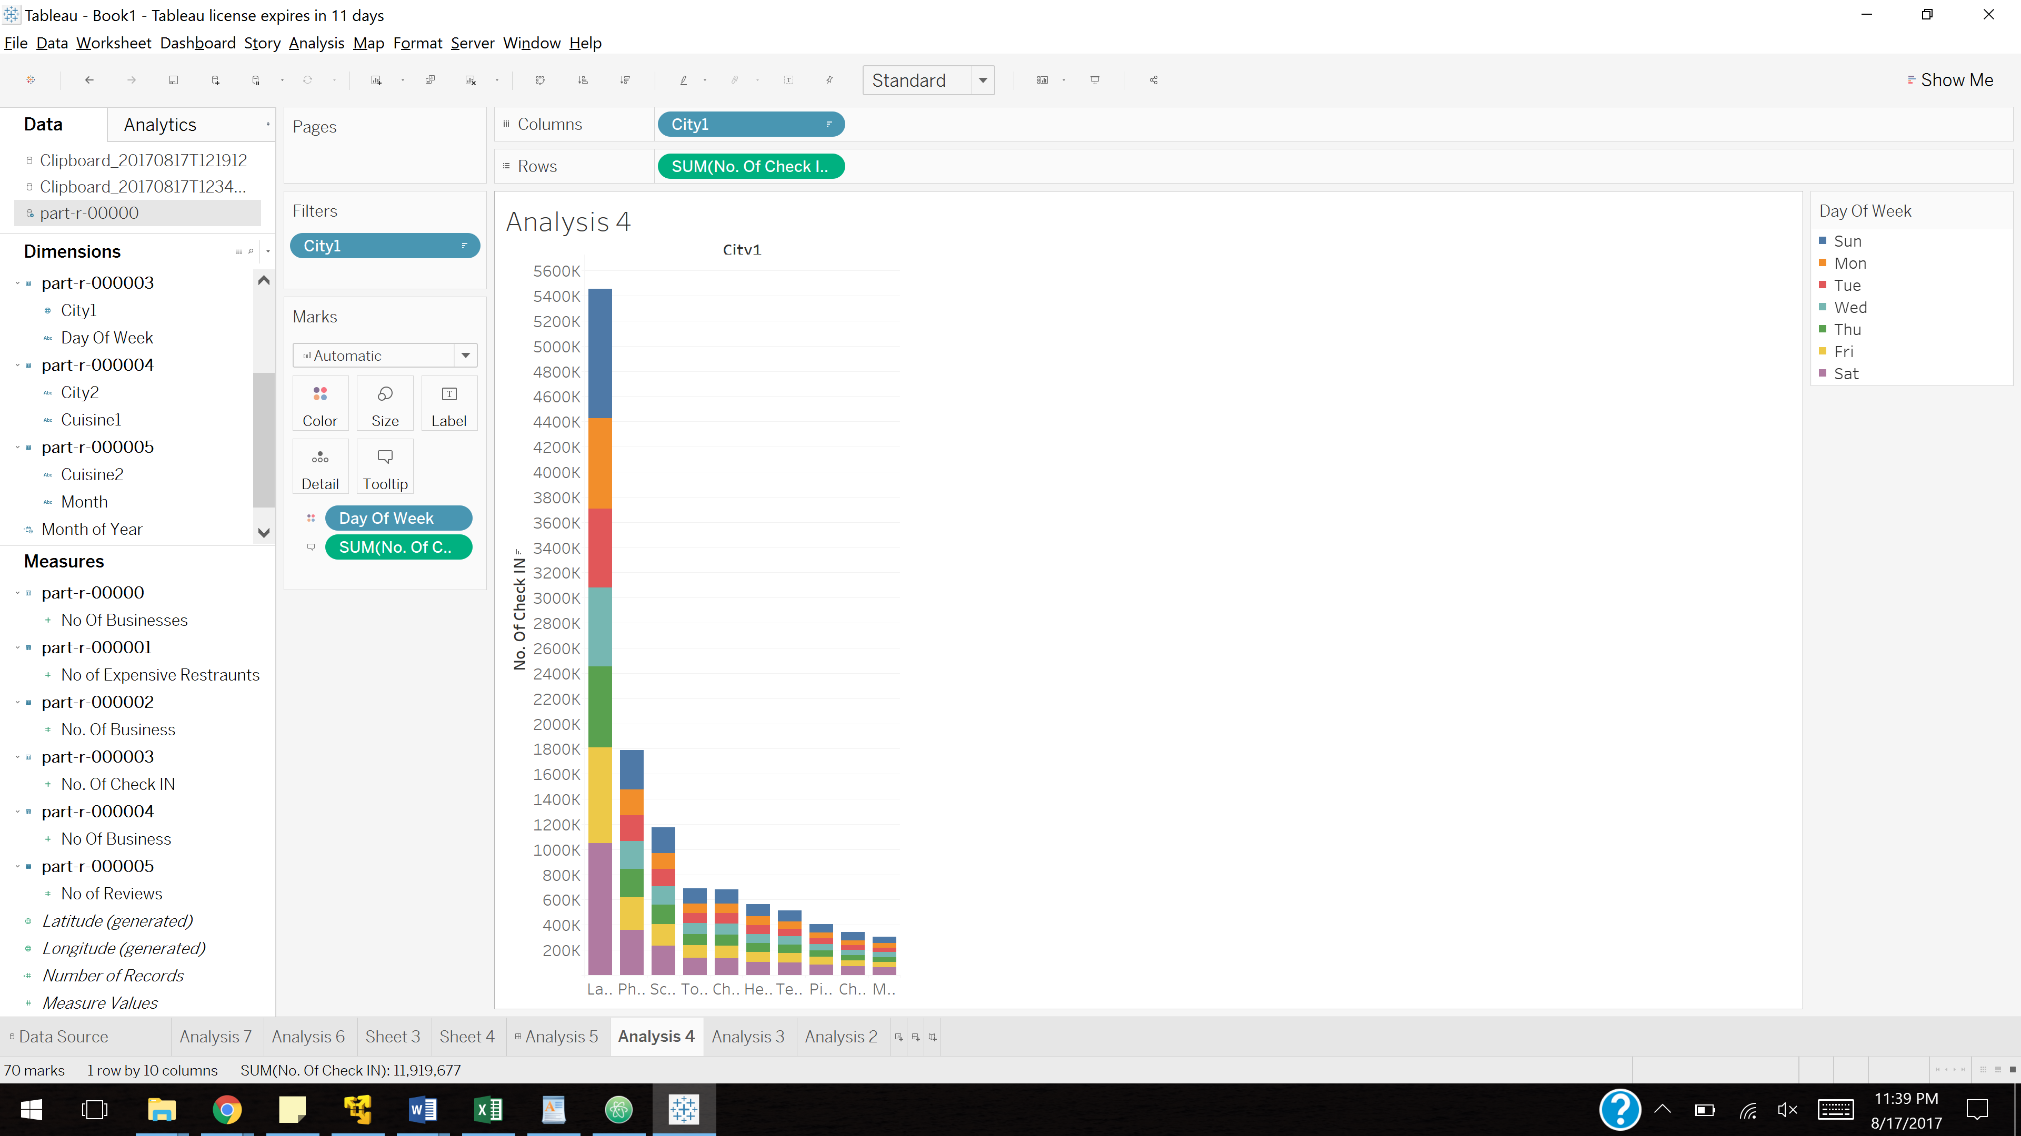

**Analysis 5**: Finding which cities has the most businesses open after hours

Steps:

1. Run analysis 5 of Hadoop
2. Run analysis 5 of pig

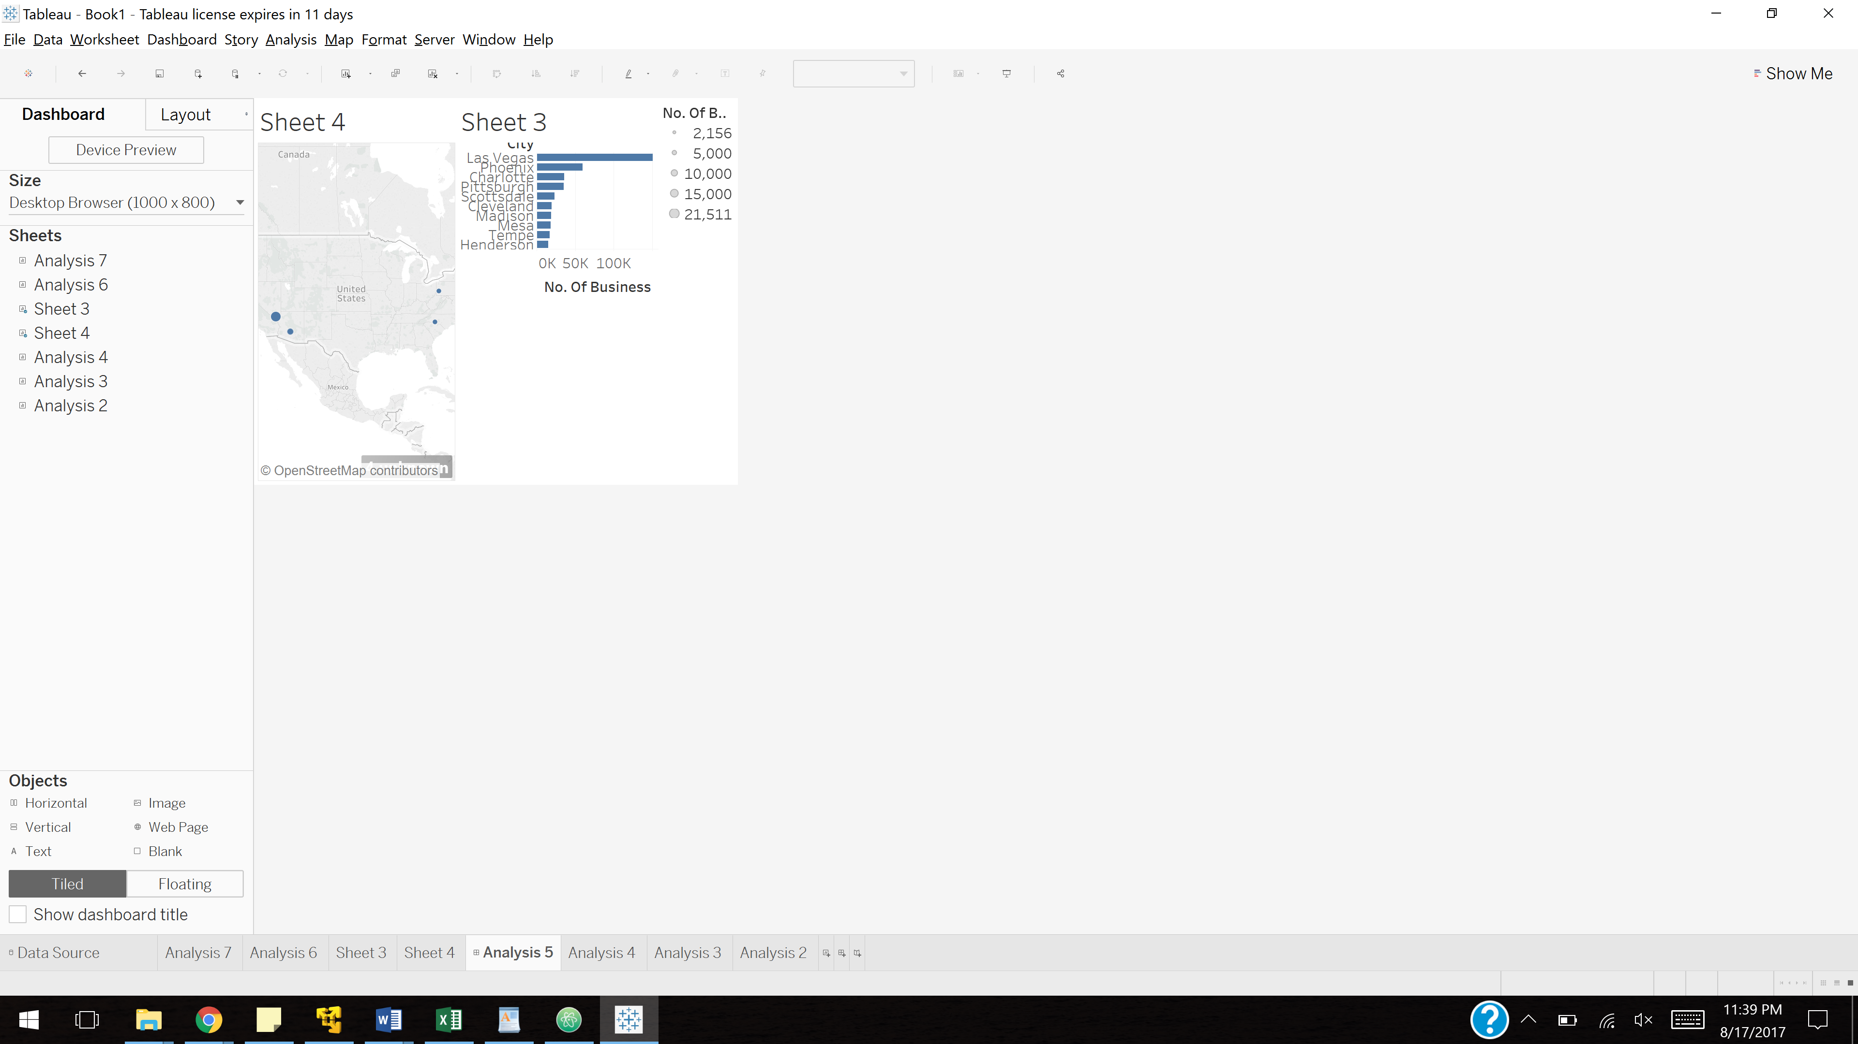

**Analysis 6**: Finding the most expensive cuisines

Steps:

1. Run analysis 6 of Hadoop
2. Run analysis 6 of pig

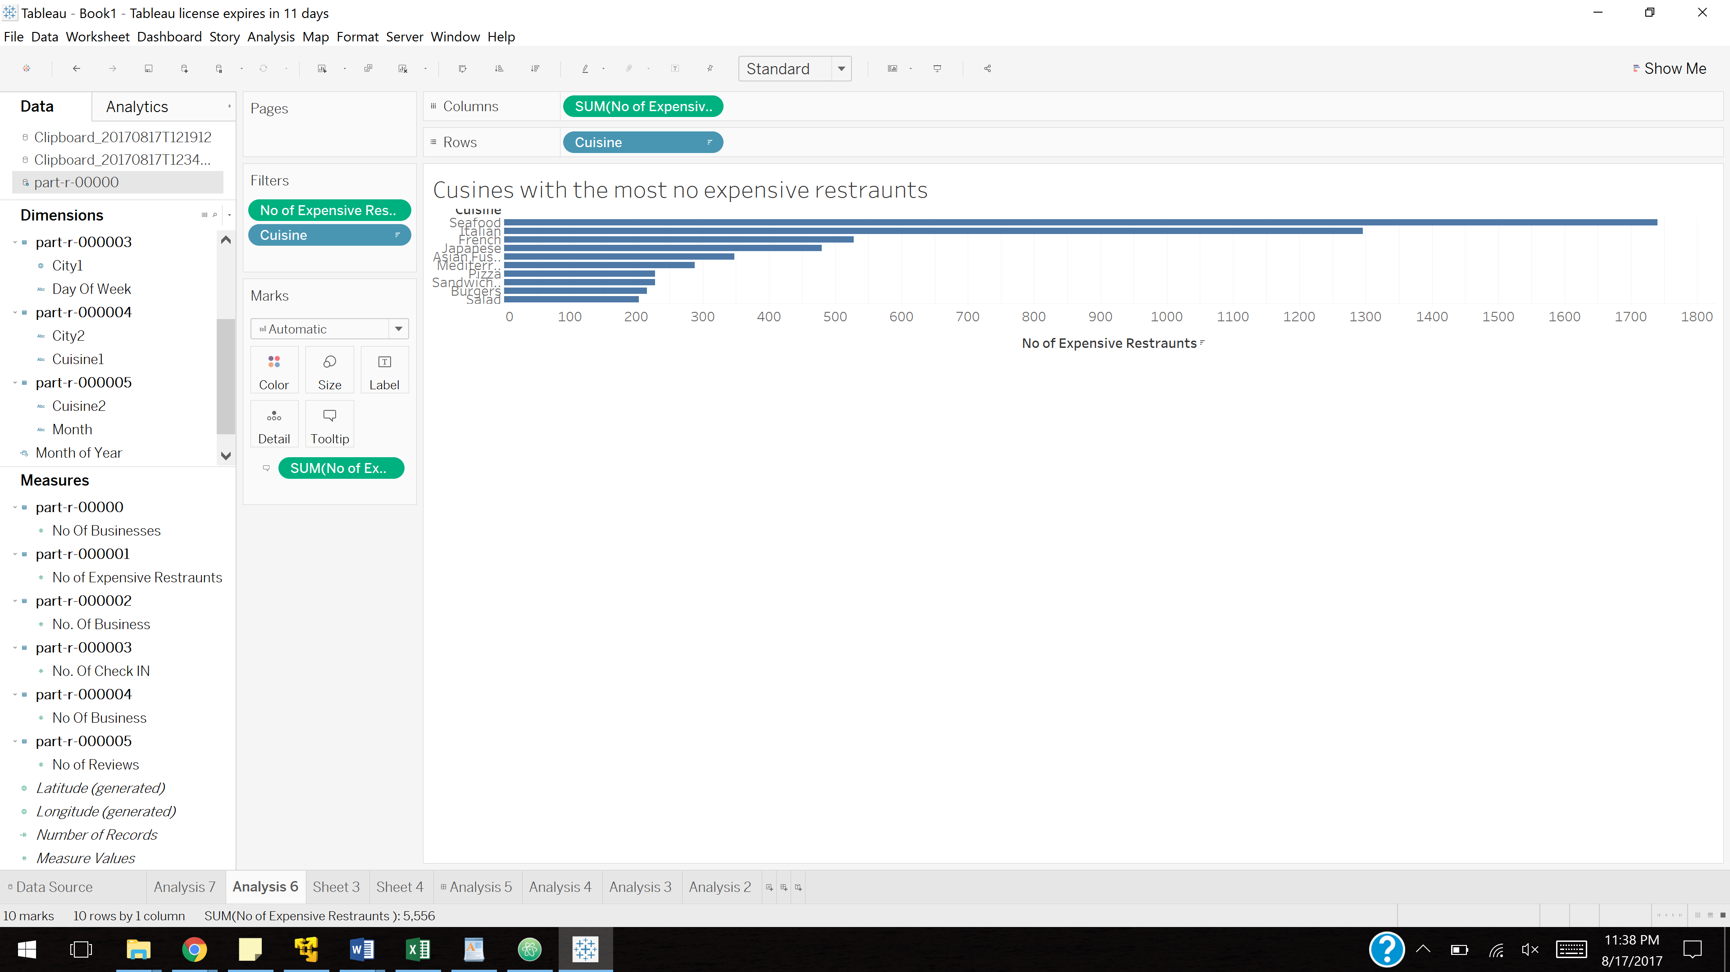

**Analysis 7**: Finding which businesses are underrated, overrated and properly rated using sentiment analysis

Steps:

1. Run sentiment analysis program
2. Run analysis 7 part 1 of Hadoop
3. Run analysis 7 of pig
4. Run analysis 7 part 2 of Hadoop

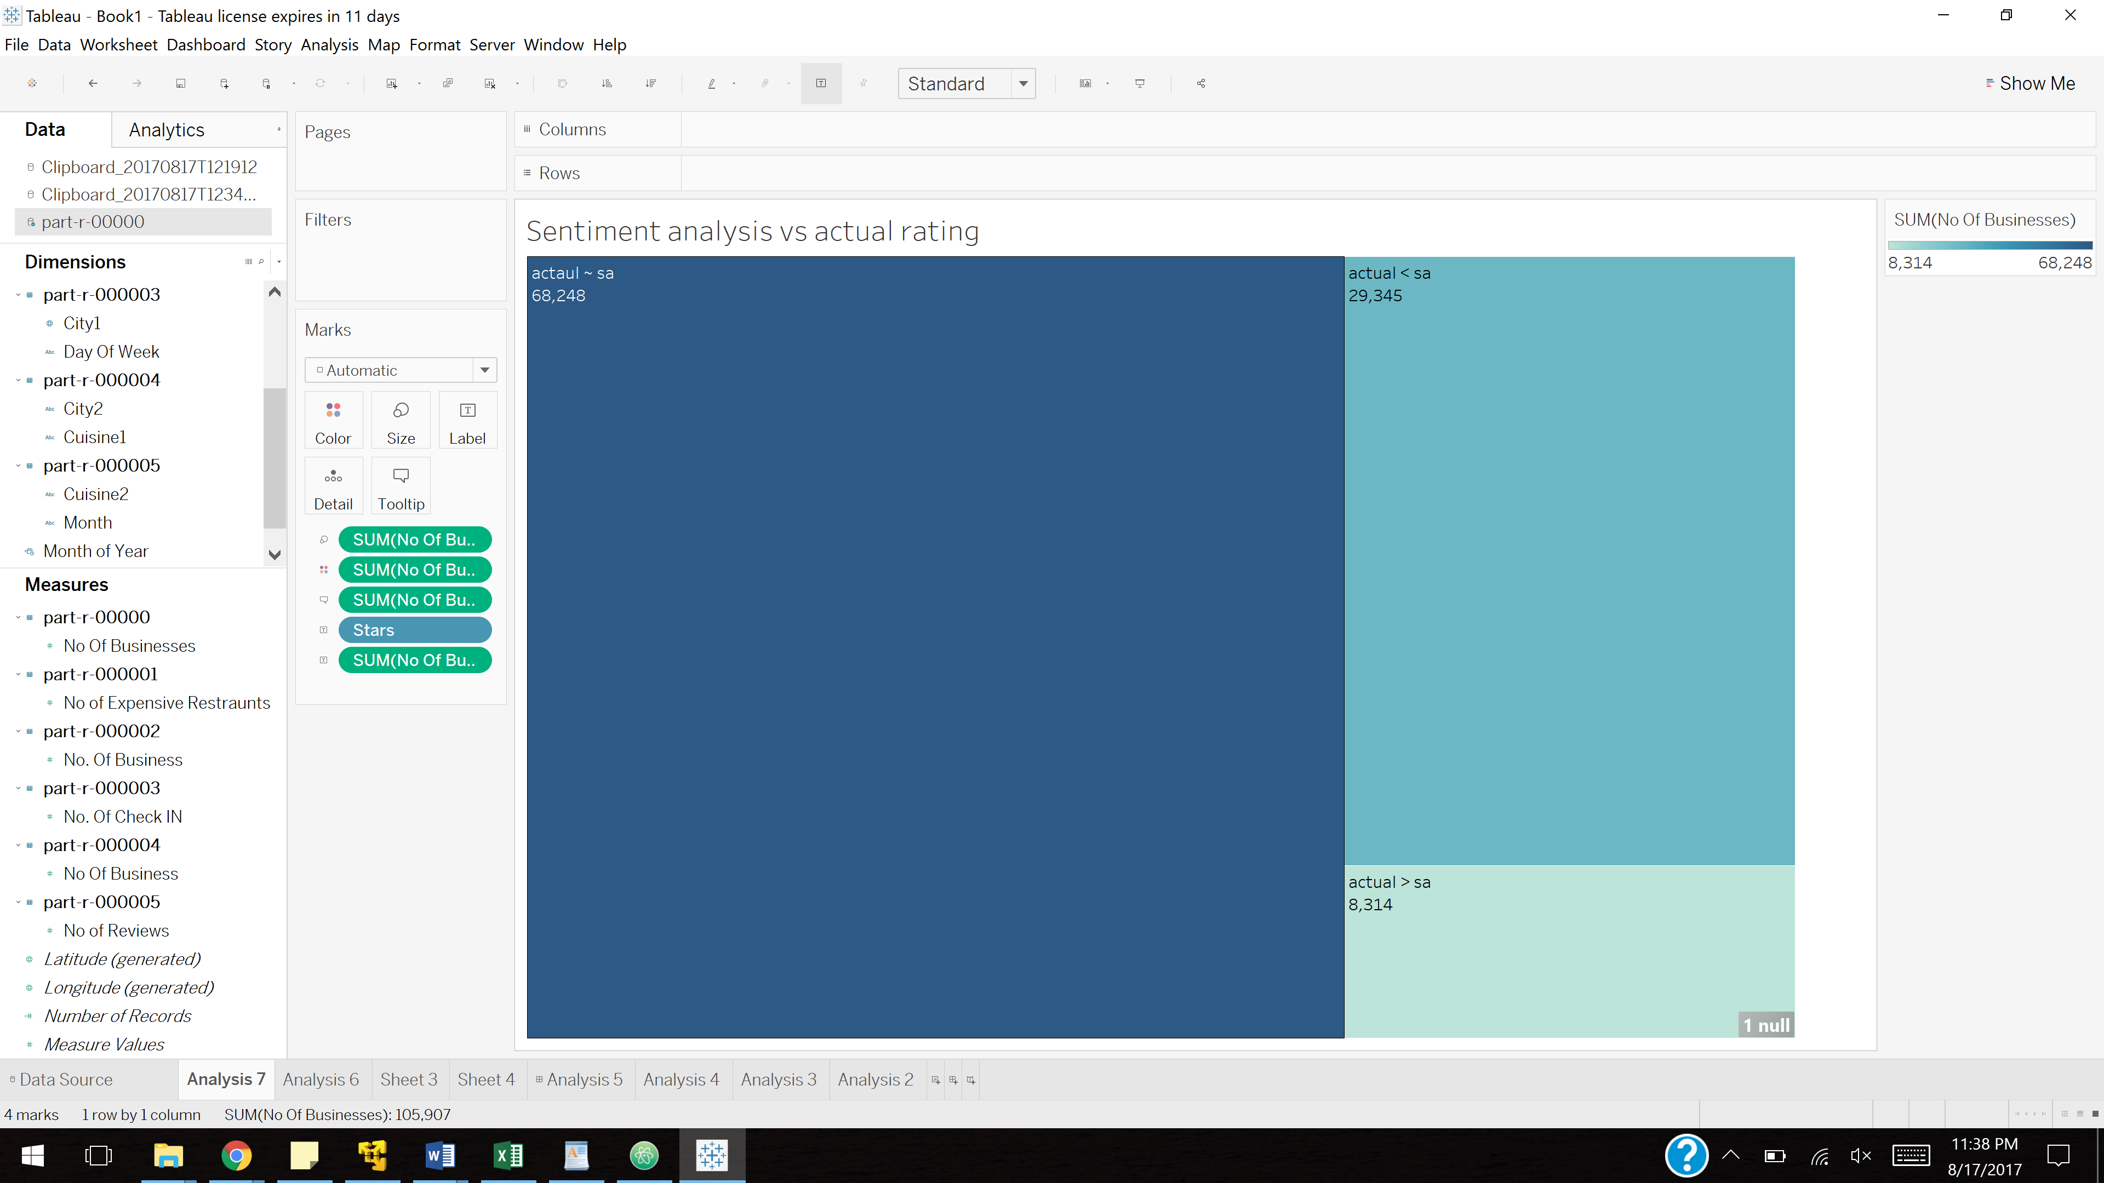

**Analysis 8**: Recommending 10 business to user based on the ratings

Steps: Run the YelpRecommender

